**Denial of Service**

**What it is**: an action that prevents or impairs the authorized use of networks, systems, or applications by exhausting resources

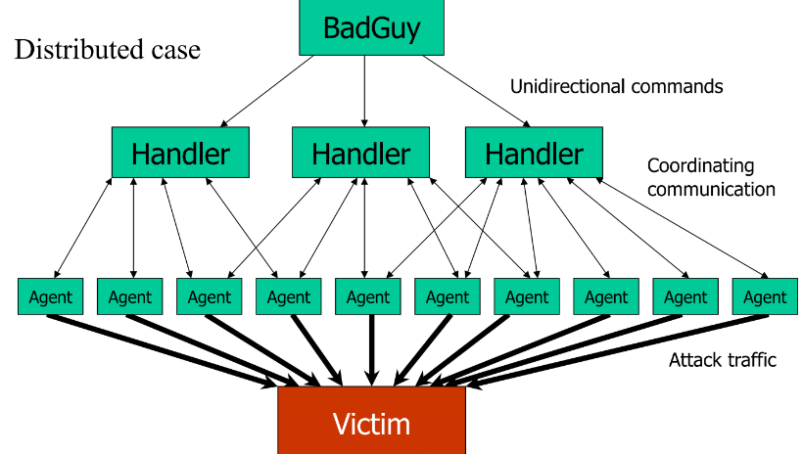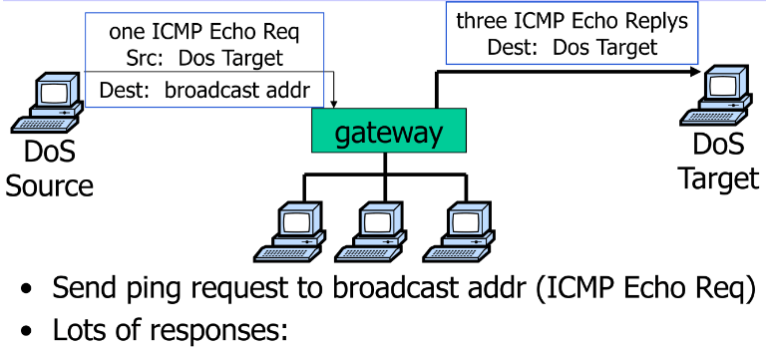**Smurf attack**

**Degree of Automation:** Manual, Fullauto,Semiauto 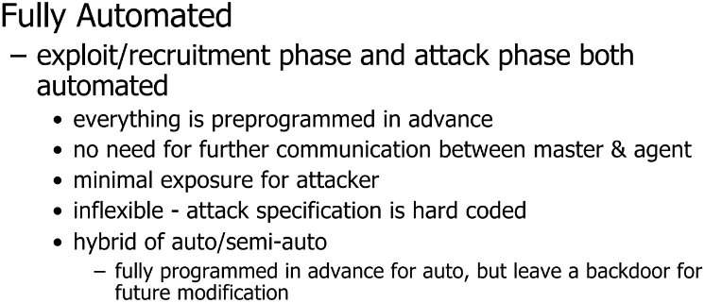 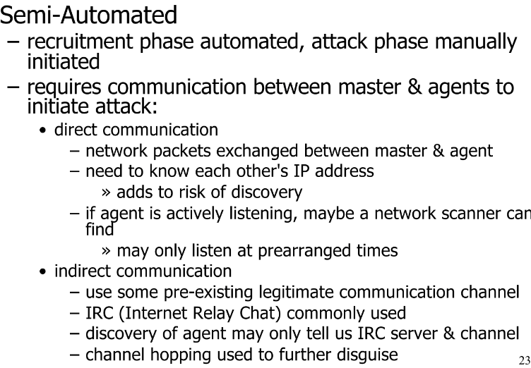

**Scanning Strategy**

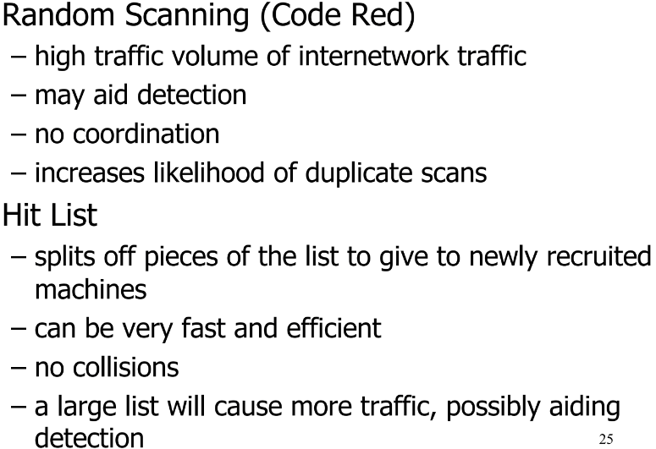 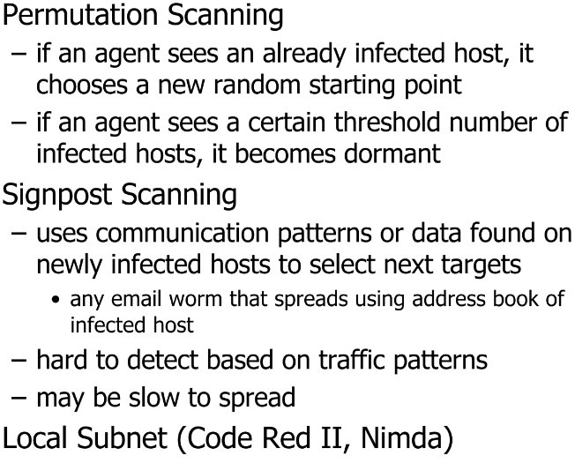

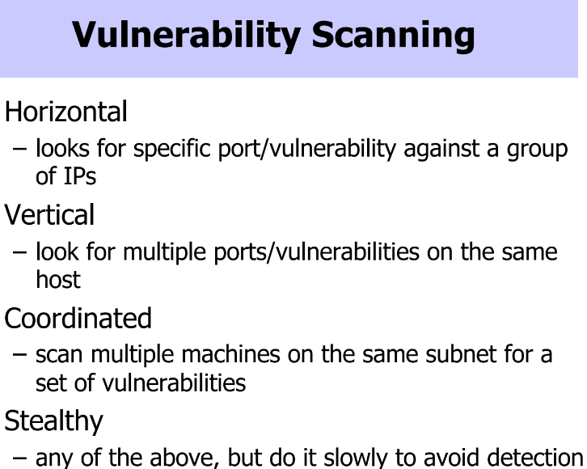 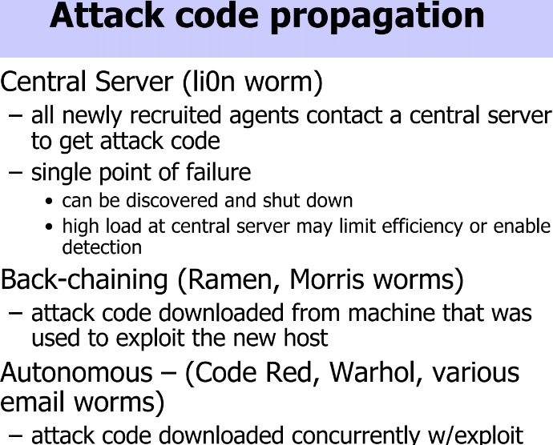

**Propagation^**

**Exploited Weakness**

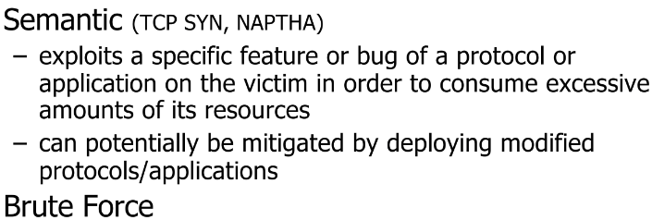 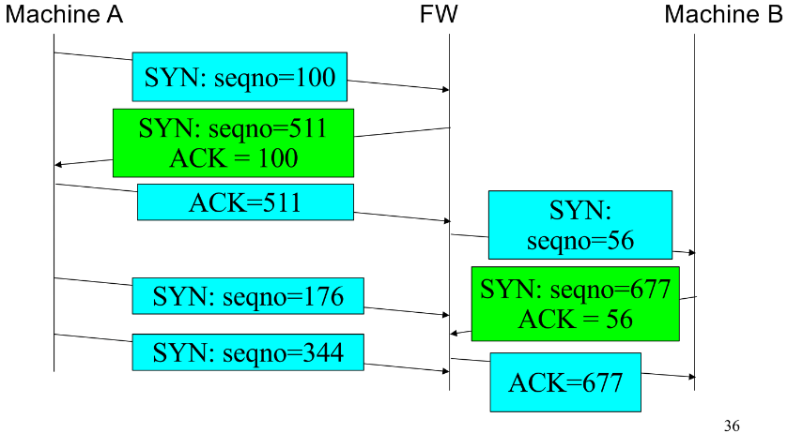

**DEEs**

Backscatter, Egress, ingress filtering, cookies (syn) ,3 way handshake, ASV , Capatcha

**SDN:**

Decouple data (pkt processing) and control planes (distribute algs)

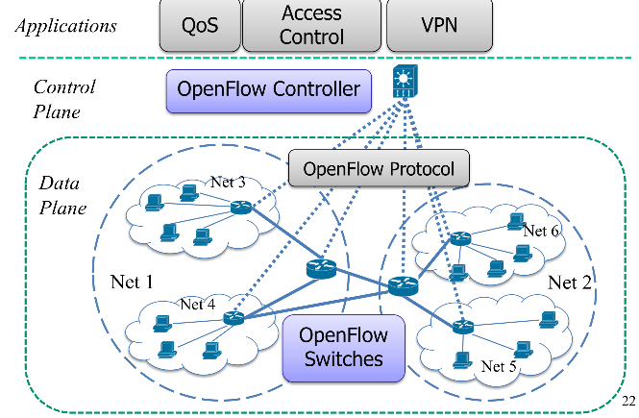

**Applications**

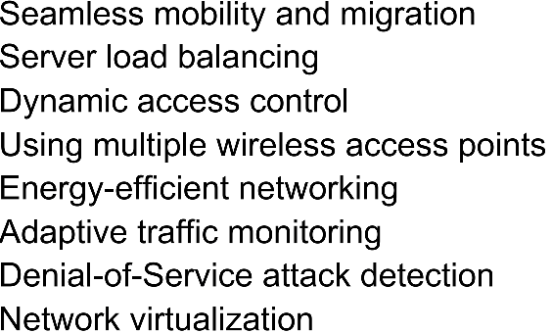

**Benefits:** realtime verif. Std open interface

**Challenges:**

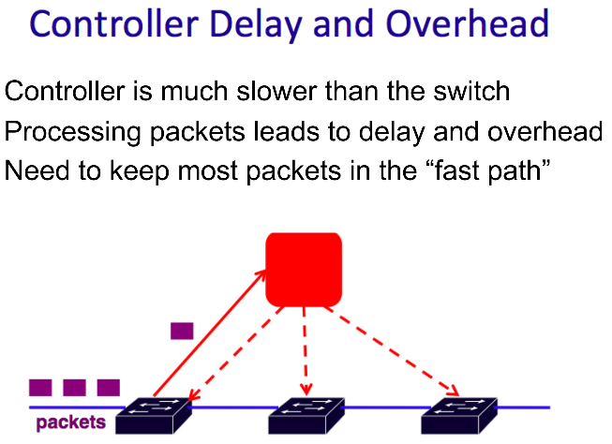 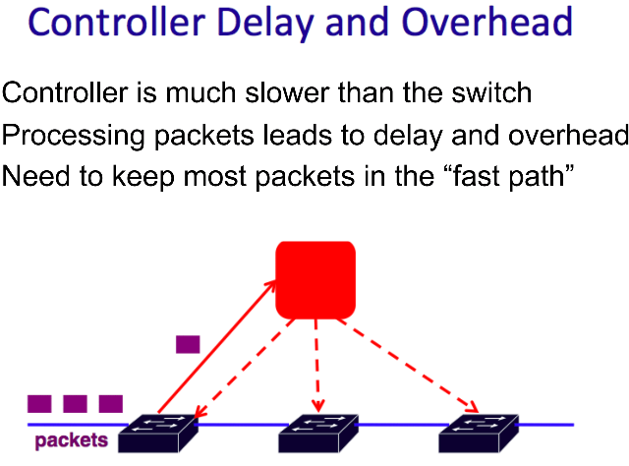

A logically-centralized network applications allow bugs occur due to the increases in software complexities. -The use of multiple applications or user’s ability to program the same physical network simultaneously, could result in conflicting rules.

**Veriflow:**

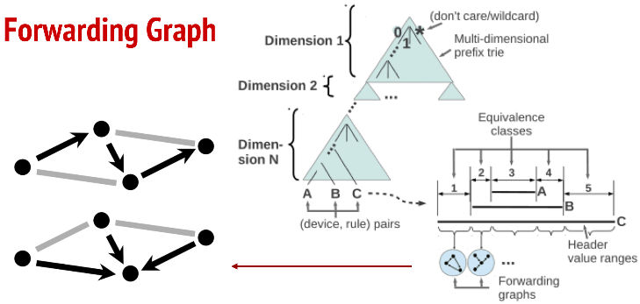

**Critical Infrastructure Protection:**

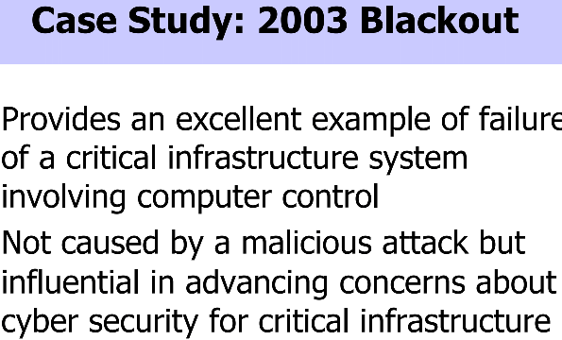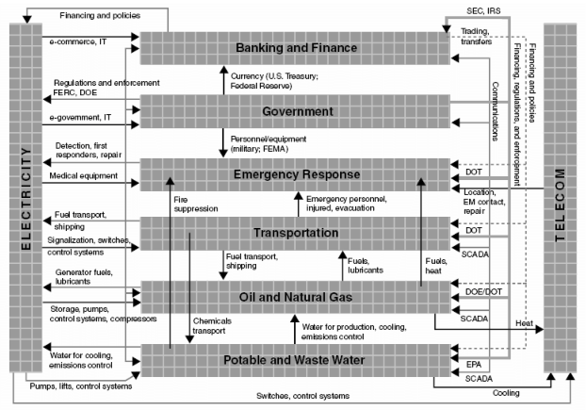

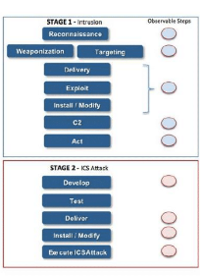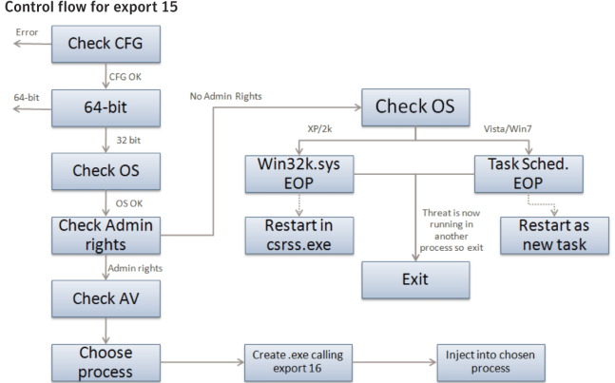

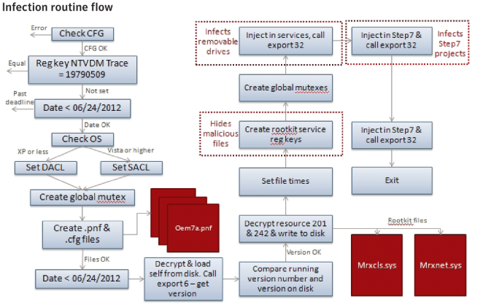

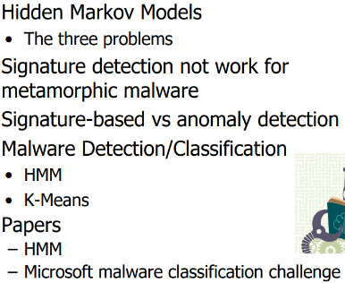**HMMs:**

**(1)The Evaluation Problem**Given an HMM tex2html_wrap_inline2676 and a sequence of observations  tex2html_wrap_inline2682 , what is the probability that the observations are generated by the model, tex2html_wrap_inline2684 ?

**(2)The Decoding Problem**

Given a model tex2html_wrap_inline2676 and a sequence of observations tex2html_wrap_inline2682 , what is the most likely state sequence in the model that produced the observations?

**(3)The Learning Problem**

Given a model tex2html_wrap_inline2676 and a sequence of observations tex2html_wrap_inline2682 , how should we adjust the model parameters tex2html_wrap_inline2694 in order to maximize tex2html_wrap_inline2696

**SPAM:**

* Unsolicited Email is normal email  
  (examples: first contact enquiries, job enquiries, sales enquiries)
* Bulk Email is normal email  
  (examples: subscriber newsletters, customer communications, discussion lists)

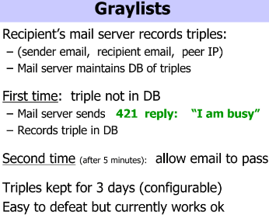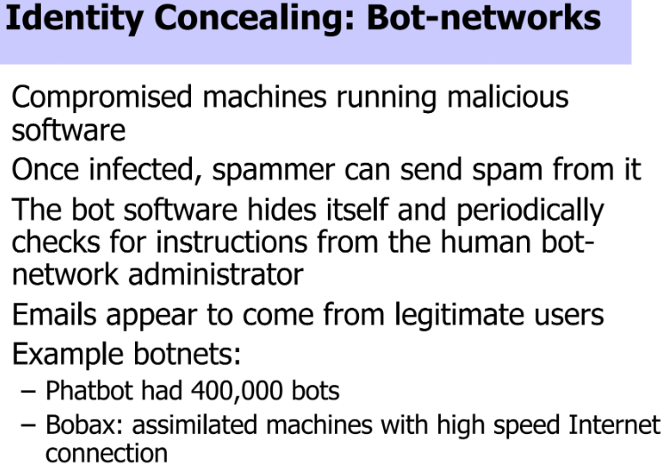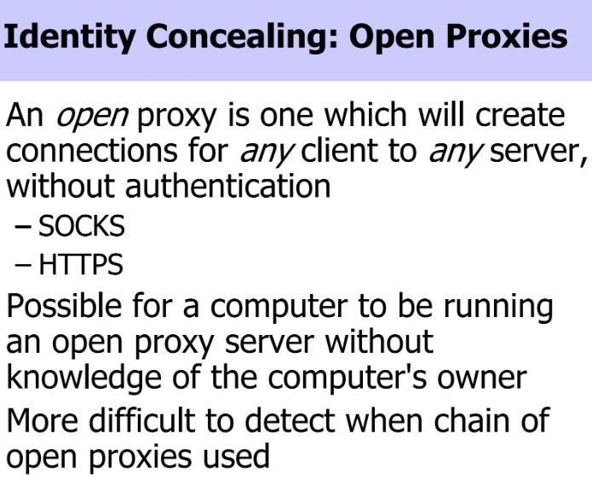or untracable internet connection

**SPAM PROTECTIONS:**

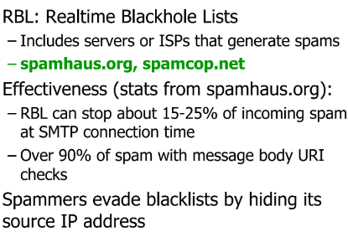 Or sender verification (SPF) or CAPATCHA

(SPF): 